5 September 2025
Dear Parents & Carers

Year 11 Newsletter
Welcome back Year 11! Year 11 is such a fantastic year, full of learning, enrichment, trials and rewards! It is a big year for both students and parents. Rest assured we are here to help you all throughout a very busy year. I would like to take this opportunity to share with you some of the amazing activities and events that will be taking place this half term and let you know about our future plans.
After School Enrichment
Our enrichment programme begins this week! It was inspiring to see so many students commit to enrichment in Year 10 and we want the same level of dedication this year. Enrichment starts immediately after period 5 and students will be expected to stay until 3.20pm, we finish at this time to allow for those students who catch the bus home. It is important that all students attend enrichment to ensure they have the best chance of succeeding in their forthcoming trials and assessments. We really do need your support in reinforcing the expectations around enrichment.

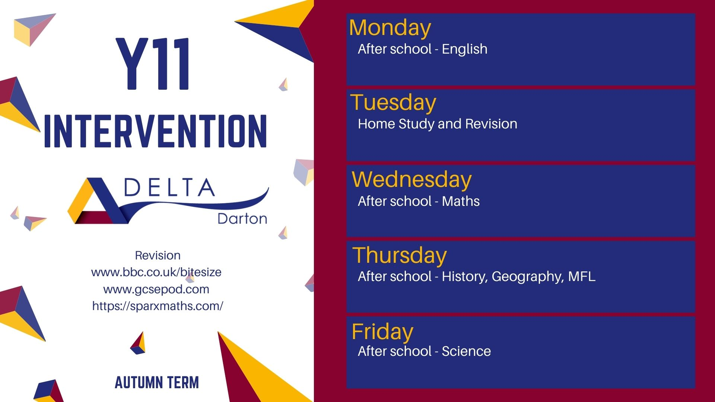

Pie Night
I would like to invite you to our GCSE preparation and revision evening on Tuesday 16th September 2025. The evening will start promptly at 5pm with the opportunity to speak to subject teachers and subject leaders about your child and what can be done to further support them. Students will collect free revision guides, exam specific revision sheets, past examination papers and other valuable resources. We hope you will join us afterwards to enjoy pie and peas for tea!
October trial examinations
Our first round of Year 11 trial examinations will take place W/C 6th October and students will sit exams in English and maths. Students are already preparing for these assessments in lessons. After the trials we will analyse students results and discuss any support that your child may need to help them continue to progress and achieve.

Home Learning
Please could you encourage your child to access their online learning packages as much as possible, home learning is set weekly. Students are using Sparx for both Maths and Science, GCSEPod for English Literature revision and Language Nut for any students studying a language. All students have their login details. We will be running parental workshop on Pie Night to help you navigate the platforms and if you have any other questions regarding home learning, please contact Mr Gibson (info@dartonacademy.org.uk) who is leading on this agenda this academic year.

Rewards and celebrations
At the end of this half term, I will be planning a reward ‘shopping trip’ on the 24 October 2025. Students who attend 15 or more enrichment sessions, maintain excellent attendance and do not receive any behaviour sanctions will be eligible to go on the trip. I want to take the entire year group with me, so please encourage your child to do their best and they will get to enjoy their reward at the end of October.

I would like to thank you for your continued support and if you have any questions about the above do not hesitate to contact me via info@dartonacademy.org.uk.

Kind regards,

Mrs K Gibson
Vice Princpal

